LAB ASSIGNMENT 3
SCHOOL OF ENGINEERING AND TECHNOLOGY
COURSE CODE AND NAME : OPERATING SYSTEM LAB ENCA252
PROGRAM NAME : BSC(DATA SCIENCE)
TITLE : Round Robin Scheduling.
OBJECTIVE : Round Robin scheduling aims to allocate CPU time equally to each process using a fixed time quantum.

Example Data:
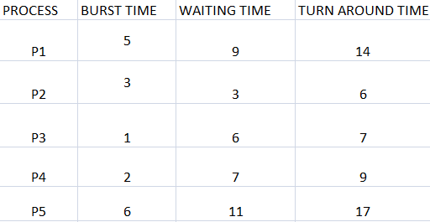

OUTPUT:
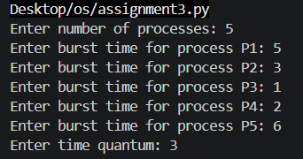

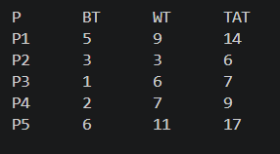
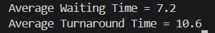
Why this example is good
Shows fair CPU sharing.
Includes both short & long processes.
Easy to understand and calculate.
Conclusion :
Round Robin scheduling gives equal CPU time to all processes and prevents starvation.

